COAL Assignment 03
ROLL NO. 22F -3441
SECTION BSCS-3D
CODE 1:
var2: db 0,0,0,0
start:
mov ax, [var2]
mov bx,0
mov cx, 10
loop1:
mov dx,0
div cx
mov [var2+bx], dx;
add bx,1

cmp ax,0
jne loop1
mov si,0

loop2:
mov al,[var2+si]
add si,1

mov dl,[var2+bx-1]
sub bx,1

cmp ax,dx
jne exit
cmp bx,1
jne loop2

mov cx, 1
exit:
mov ax, 0x4c00
int 0x21
OUTPUT:
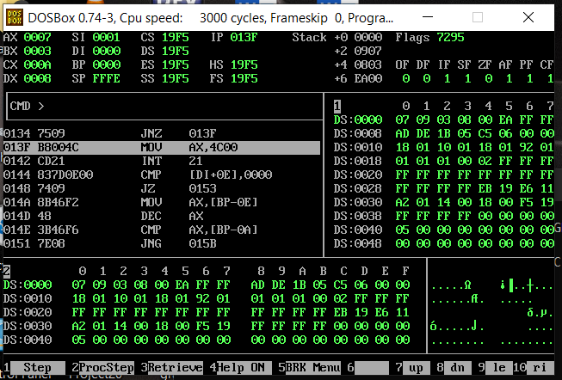
CODE 2:
org 0x100
jmp start
var: dw 3
factorial: dw 0

start: mov ax, 1
mov cx, [var]

l1: mul cx
dec cx
jne l1

mov [factorial], ax

mov ax, 0x4c00
int 0x21

OUTPUT:
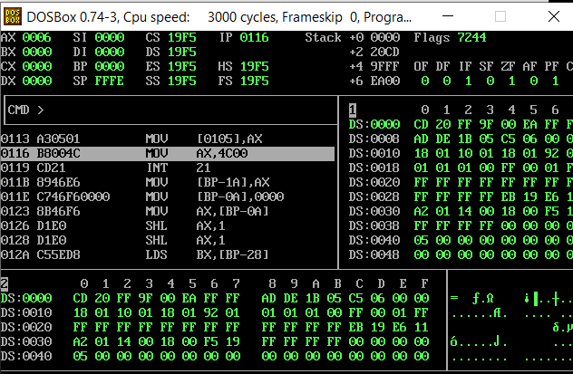
CODE 3:
org 0x100

jmp start
dec_var: db 15
binary_var: db 0, 0, 0, 0, 0, 0, 0, 0, 0

start: mov ah, 0
mov al, byte[dec_var]
mov cx, 8
mov bx, 0

l1: shl al, 1
rcl byte[binary_var+bx], 1
add bx, 1
dec cx
jnz l1

mov ax, 0x4c00
int 0x21
OUTPUT:
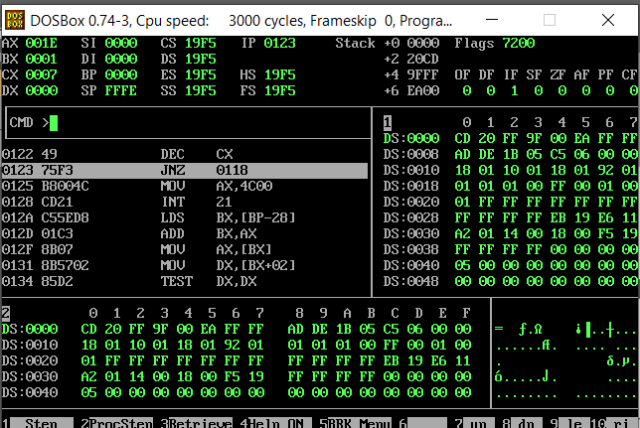
CODE 4:
org 0x100
jmp start
num4: dw 60, 55, -55, 60,-60, 58, -58, -58, 25, 15, 34, 87, 90, 12, 65
swap: db 0

start: mov bx, 0
mov byte [swap], 0

l1: mov ax, [num4+bx]
cmp ax, [num4+bx+2]
jge skipswap
mov dx, [num4+bx+2]
mov [num4+bx+2], ax
mov [num4+bx], dx
mov byte [swap], 1

skipswap: add bx, 2
cmp bx, 28
jne l1
cmp byte [swap], 1
je start

mov ax, 0x4c00
int 0x21
OUTPUT:
